

Web Design
Proposal
Prepared for:
Madlenya FC
Prepared by:
76957019 / 79183094

Executive Summary
This proposal outlines the development of a comprehensive website for Madlenya FC to enhance its digital presence, engage with fans, and optimize operations. By leveraging the power of the internet, the website will serve as a central hub for information, communication, and fan interaction, ultimately contributing to the club's growth and success.

Problem Statement
In today's digital age, a strong online presence is essential for sports organizations to connect with fans, build brand loyalty, and generate revenue. Madlenya FC currently lacks a dedicated website, limiting its ability to reach a wider audience, share club news and updates, and engage with the community.

Proposed Solution
The development of a user-friendly and visually appealing website will address these challenges by providing the following key features:
- Club Information: Detailed information about the team's history, mission, vision, and values.
- Team Roster: Profiles of players, including statistics, photos, and biographies.
- Match Schedule and Results: Up-to-date fixtures, results, and league standings.
- News and Updates: Regular news articles, match reports, and press releases.
- Fan Engagement: Interactive features such as forums, polls, and contests.
- Merchandise Store: Online shop for club merchandise.
- Social Media Integration: Integration with the club's social media channels.
- Responsive Design: Optimization for desktop, tablet, and mobile devices.

Benefits of the Website
- Enhanced Fan Engagement: A platform for fans to connect with the club and each other.
- Increased Brand Awareness: Wider reach and visibility for the team.
- Improved Communication: Effective dissemination of club news and information.
- Revenue Generation: Potential for online merchandise sales.
- Data Collection: Valuable insights into fan behavior and preferences.

Development Schedule
Based on our experience with web design and web development projects we have created the below web development schedule.

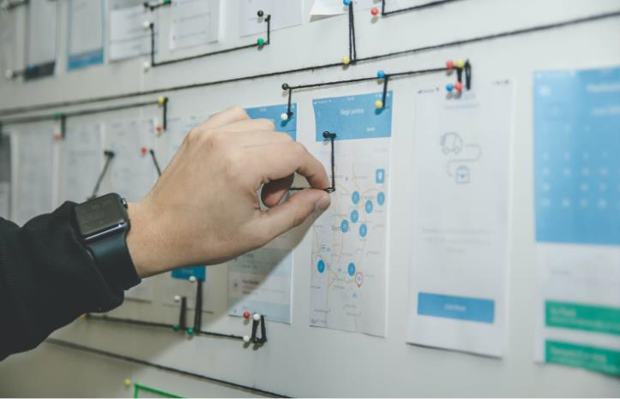
Project Roadmap
First, we'll sit together with all stakeholders to put a detailed list of all project requirements. We'll identify the major milestones to follow, so we can keep an eye on what comes next and be able to assess our progress.
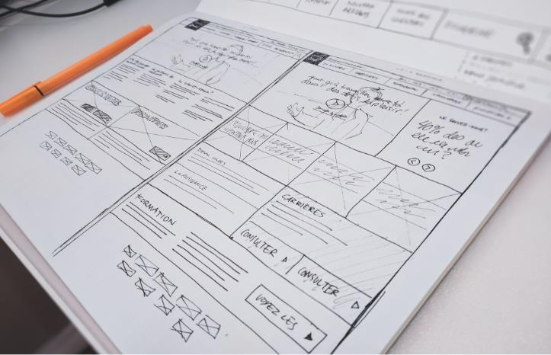
⇓

Wireframes
At this stage, you'll have the chance to see what your future website will look like. The wireframes are not as detailed as the final designs however, they give a good idea about what the general layout of the website will be.
⇓


Design Versions
We'll present you with a couple of design versions. Once you pick up one of them, we'll make as many tweaks and changes as needed in order to reach to the final website design.
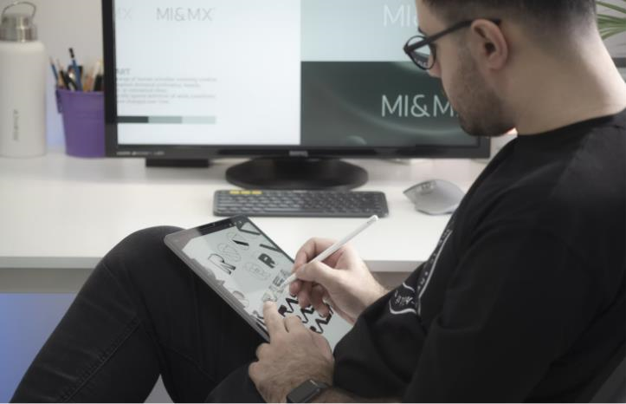
⇓

Texts & Images
As soon as the website design is ready, we'll need your photographer you're working with to arrange a photo shoot with the players and team members.
⇓


Web Development
While you're working on the copy and sourcing the images for the website, we'll start with the coding work. We'll do the front-end development.
⇓

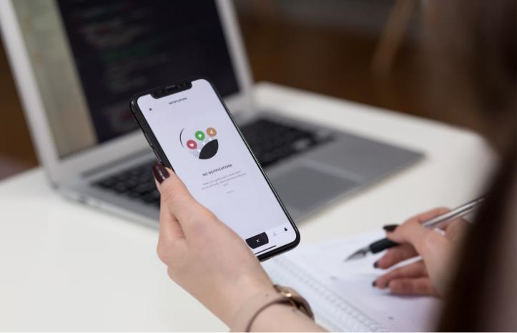
Testing
In the end, to makes sure that every menu and every functionality on the website work as expected, we'll hand the website to our team testers. Along with that, we'll also ask you to have a look at the website with your team and report any bugs you may find.
Conclusion
A website is a powerful tool for Madlenya FC to connect with fans, build its brand, and achieve its goals. By investing in this project, the club will enhance its digital presence, improve communication, and create new opportunities for growth.
We are confident in our ability to deliver a high-quality website that exceeds your expectations. We look forward to the opportunity to partner with Madlenya FC on this exciting project.
Contact: 76957019 / 79183094

